Part Number: PT944-33190-02 (Gas)

PT944-33191-02 (Hybrid)
Kit Contents
Item # | Quantity Reqd. | Description
1 | 1 | Trunk Sill
2 | 1 | Hardware Kit
Hardware Bag Contents
Item # | Quantity Reqd. | Description
1 | 11 | 15cm Wire Tie
2 | 1 | Foam Tape 90mm x 30mm
3 | 1 | Foam Tape 90mm x 60mm
4 | 1 | Clip
5 | 2 | Foam Tape 45mm x 30mm
Additional Items Required For Installation
Item # | Quantity Reqd. | Description
1
2
3
Conflicts
None
Recommended Tools
Personal & Vehicle Protection | Notes
Safety Glasses
Safety Gloves | Optional
Vehicle Protection | Blanket
Special Tools | Notes
Panel Removal Tool | To remove Passenger Lower  Dash Panel
Installation Tools | Notes
10mm Socket / Ratchet or 10mm Wrench | For Battery
Screwdriver | Flathead
Diagonal cutting pliers | For Zip Tie cutting
Special Chemicals | Notes
Cleaner | VDC Approved Cleaner
General Applicability
MY19 and newer ES/ESh vehicles
Recommended Sequence of Application
Item # | Accessory
1 | Illuminated Trunk Sill
2 | Cargo Net
*Mandatory
Vehicle Service Parts (may be required for reassembly)
Item # | Quantity Reqd. | Description
1
2
3
Legend
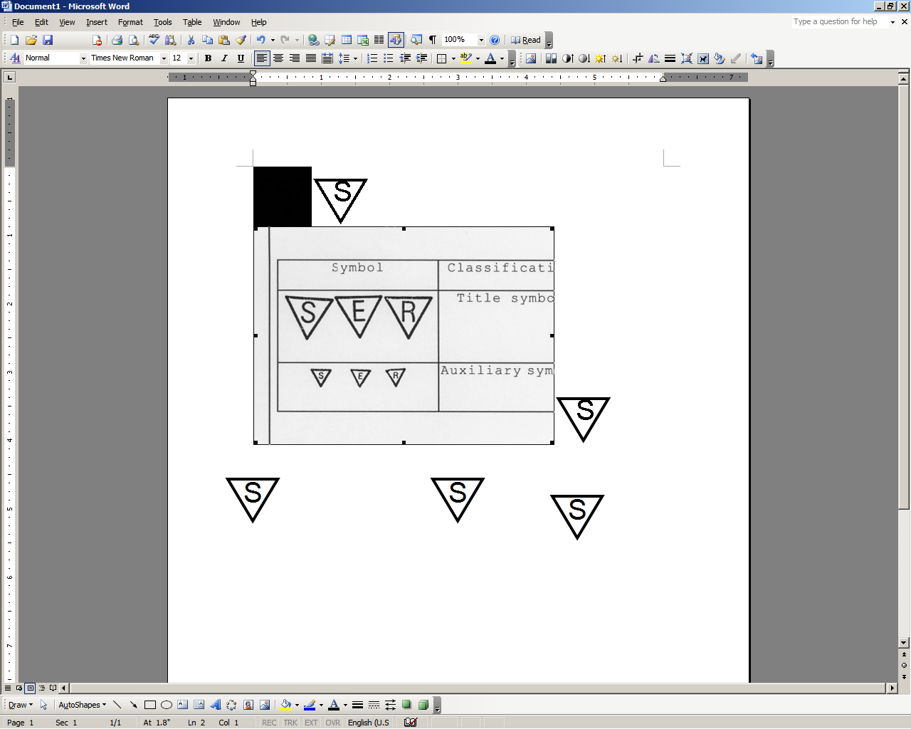




STOP: Damage to the vehicle may occur. Do not proceed until process has been complied with.
OPERATOR SAFETY: Use caution to avoid risk of injury.
CAUTION: A process that must be carefully observed in order to reduce the risk of damage to the accessory/vehicle and to ensure a quality installation.
TOOLS & EQUIPMENT: Used in Figures calls out the specific tools and equipment recommended for this process.
REVISION MARK: This mark highlights a change in installation with respect to previous issue.
SAFETY TORQUE: This mark indicates that torque is related to safety.

Care must be taken when installing this accessory to ensure damage does not occur to the vehicle. The installation of this accessory should follow approved guidelines to ensure a quality installation.

These guidelines can be found in the "Accessory Installation Practices" document.

This document covers such items as:-
- Vehicle Protection (use of covers and blankets, cleaning chemicals, etc.).
- Safety (eye protection, rechecking torque procedure, etc.).
- Vehicle Disassembly/Reassembly (panel removal, part storage, etc.).
- Electrical Component Disassembly/Reassembly (battery disconnection, connector removal, etc.).

Please see your Lexus dealer for a copy of this document.

Check Kit Content.
  - Check kit for content and damage.
    - One (1) Trunk Sill – Confirm correct vehicle model logo for Gas or Hybrid
    - One (1) Hardware Kit

Prepare the Vehicle.

  - Apply the parking brake.

  - Locate and remove the negative (-) battery terminal.

CAUTION: Do not touch the positive terminal with any tool during removal.

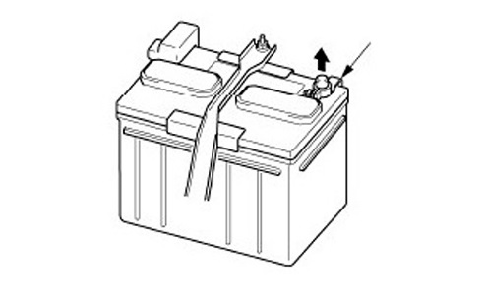
    - Remove the negative (-) battery terminal using a 10mm wrench or socket
(Fig. 2-1).
10mm Socket / Rachet or 10mm Wrench
Fig. 2-1
Negative
Battery Cable
    - Secure the negative (-) battery terminal so that it does not make intermittent contact with the battery terminals.

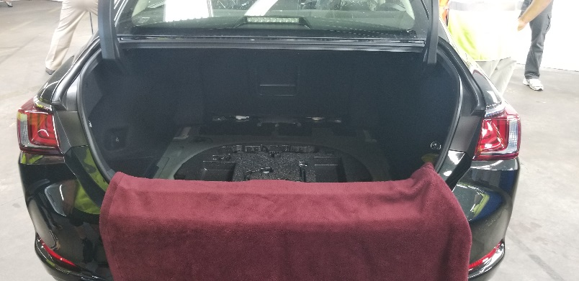
Disassemble the Vehicle.
Fig. 3-1
  - Protect the trunk opening while installing the Illuminated Trunk Sill (Fig 3-1).

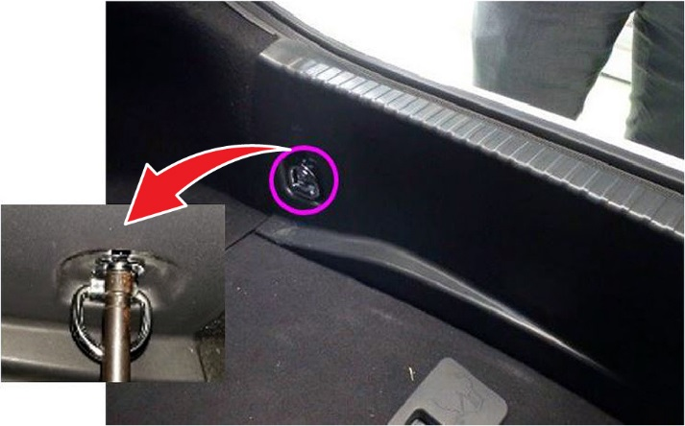
  - Remove two (2) 10mm bolts to remove D-Rings from the front of the trunk sill and retain for reassembly (Fig. 3-2 & Fig. 3-3).
Fig. 3-2
10mm Socket / Rachet

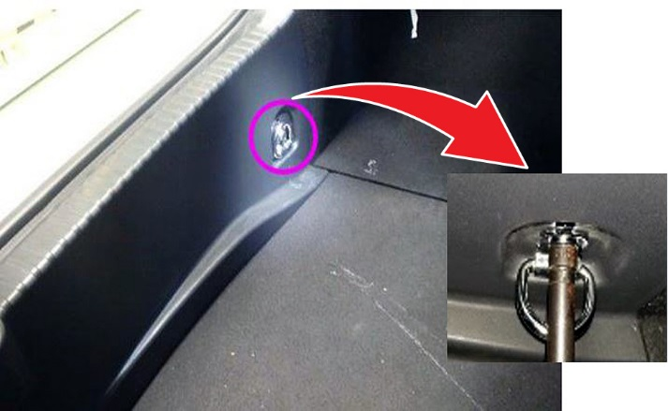
Fig. 3-3
10mm Socket / Rachet

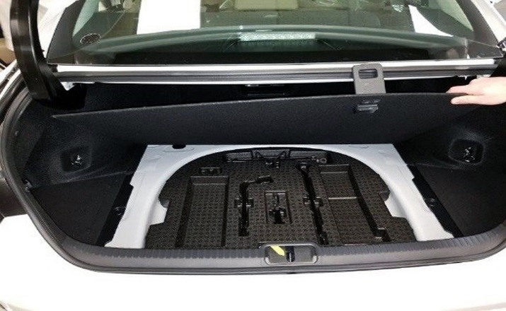
  - Remove the trunk deck board (Fig. 3-4).
Fig. 3-4

10mm Socket / Rachet
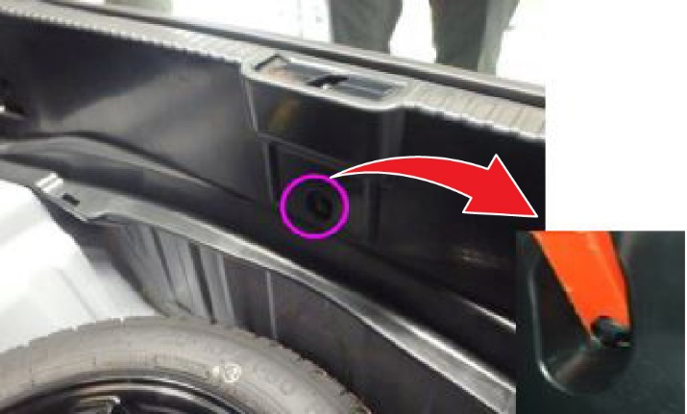
  - Remove the clip located in the center of the trunk sill using a nylon panel removal tool and discard (Fig. 3-5).
Fig. 3-5
Fig. 3-3

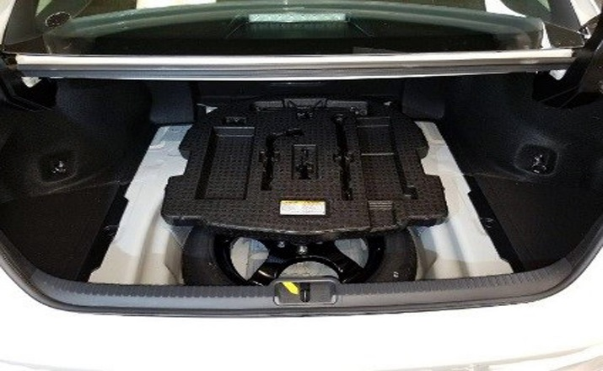
  - Move the foam tool block forward in the trunk (Fig. 3-6).
Fig. 3-6

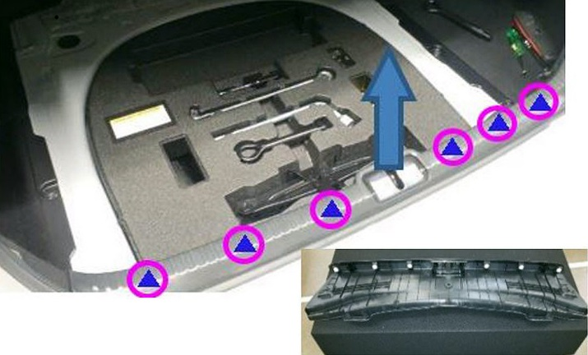
  - Remove the trunk sill by pulling up on the trunk sill to disengage the six (6) clips and discard (Fig. 3-7).
Fig. 3-7

Plastic pry tool
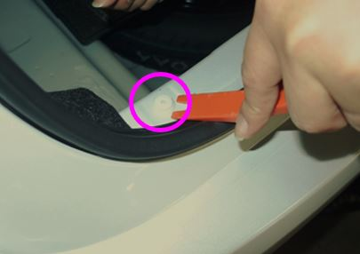
  - Ensure all six (6) clips are removed from vehicle body. If clips remain on vehicle body use a nylon panel removal tool to remove clip(s) and discard clip(s) (Fig. 3-8).
Fig. 3-8

Plastic pry tool
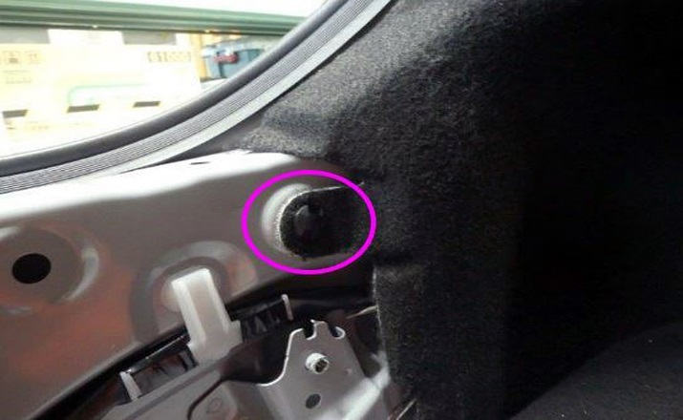
  - Remove the clip attaching the LH quarter trim panel to the vehicle body near the LH trunk opening using a nylon panel removal tool and retain for reassembly (Fig. 3-9).
Fig. 3-9

Plastic pry tool
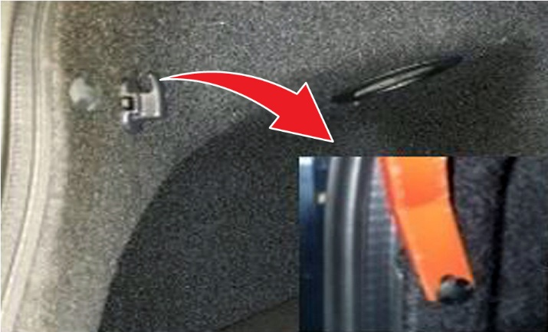
  - Remove the clip attaching the LH quarter trim panel to the vehicle body using a nylon panel removal tool and retain for reassembly (Fig. 3-10).
Fig. 3-10

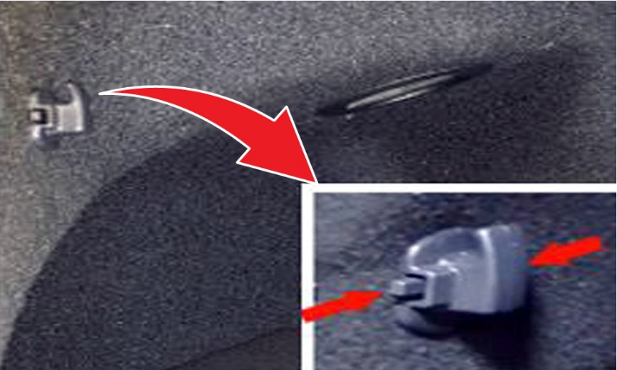
  - Remove hook from LH quarter trim panel by pressing both buttons located on sides of hook and retain for reassembly (Fig. 3-11).
Fig. 3-11

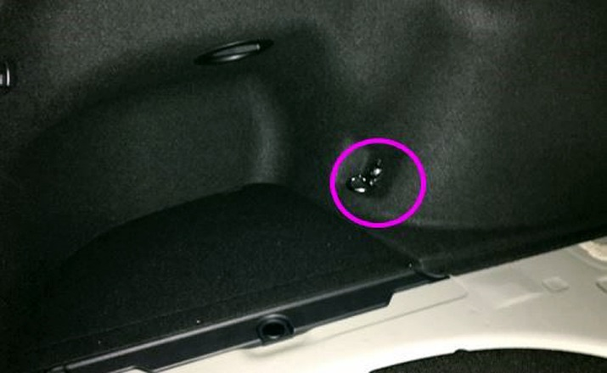
  - Remove 10mm bolt to remove D-Ring from the LH quarter trim panel and retain for reassembly (Fig. 3-12).
Fig. 3-12
10mm Socket / Rachet

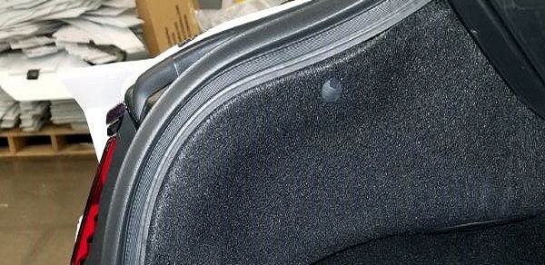
  - Remove the clip attaching the LH quarter trim panel to the vehicle body using a nylon panel removal tool and retain for reassembly (Fig. 3-13).
Fig. 3-13
Plastic pry tool

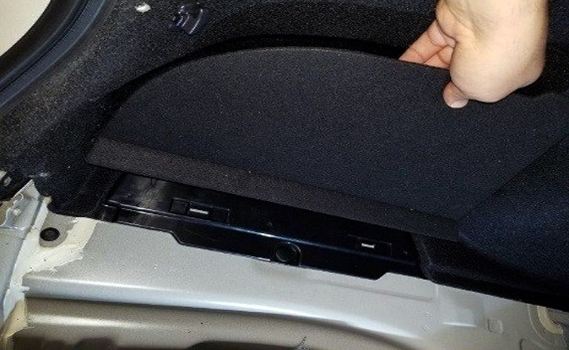
  - Remove the LH storage compartment lid using a nylon panel removal tool to pry up near lid hinges and retain for reassembly (Fig. 3-14).
Fig. 3-14
Plastic pry tool

Install the Illuminated Trunk Sill.
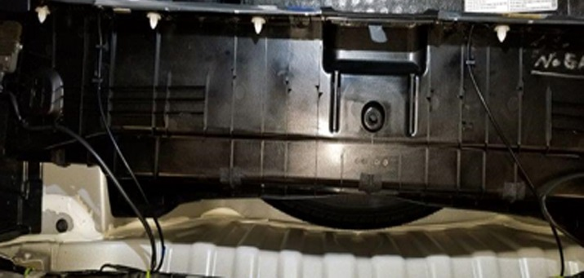
  - Place the illuminated trunk sill in the trunk (Fig. 4-1).
Fig. 4-1

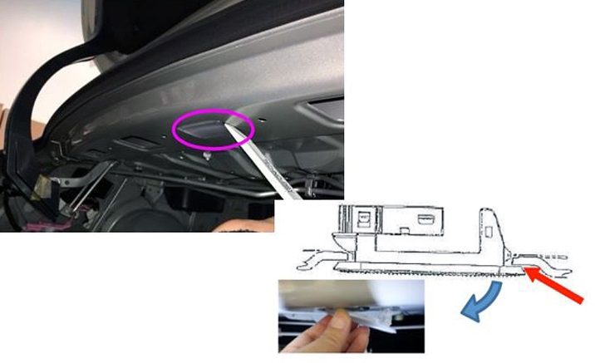
  - Remove trunk light by pressing on RH side of trunk light with a nylon panel removal tool to disengage the clip holding the light to the vehicle (Fig. 4-2).
Fig. 4-2
Plastic pry tool
  - Remove connector from trunk light and temporarily connect to illuminated trunk sill harness to confirm illumination.
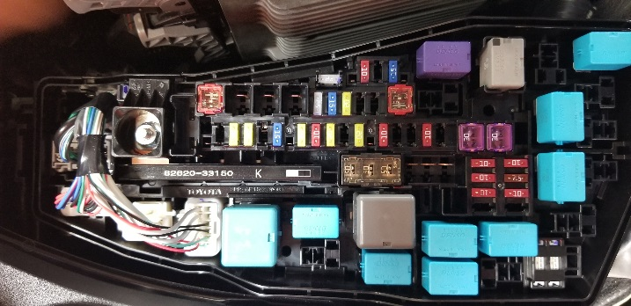
Fig. 4-3
  - Install DCC fuse located in driver side of hood if not already installed (Fig 4-3).

  - Temporarily reconnect battery.

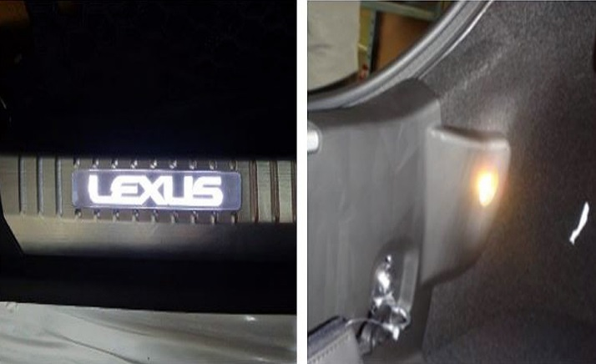
  - Verify both logos and spot lights are illuminated (Fig. 4-4).
Fig. 4-4
    - RH Logo for Gas Vehicle = ES350
    - RH Logo for Hybrid Vehicle = ES300h
  - Disconnect negative lead.
CAUTION: Do not touch the positive terminal.
  - Disconnect the trunk light harness from the illuminated trunk sill to continue with installation.
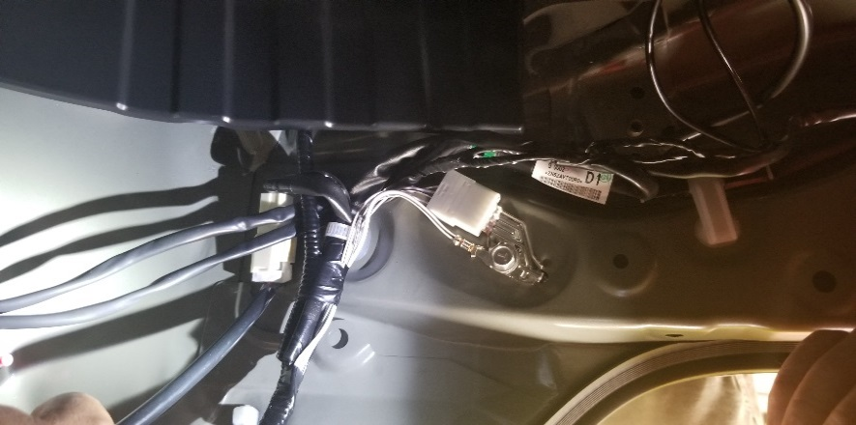
  - Route the illuminated trunk sill harness behind the opening (Fig. 4-5).
Fig. 4-5

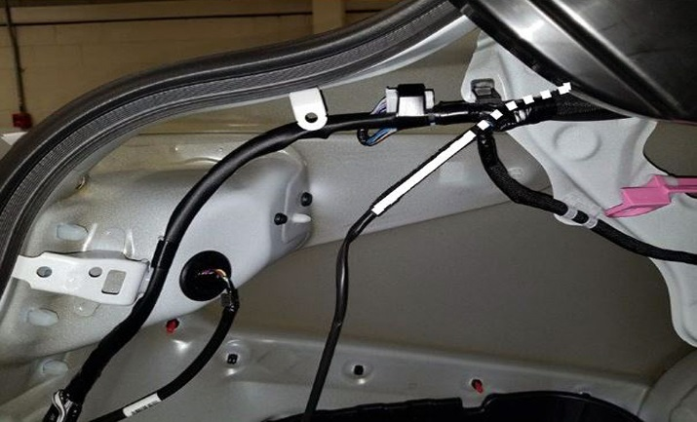
  - Route the illuminated trunk sill harness behind vehicle harness located near LH of trunk lid hinge (Fig. 4-6).
Fig. 4-6

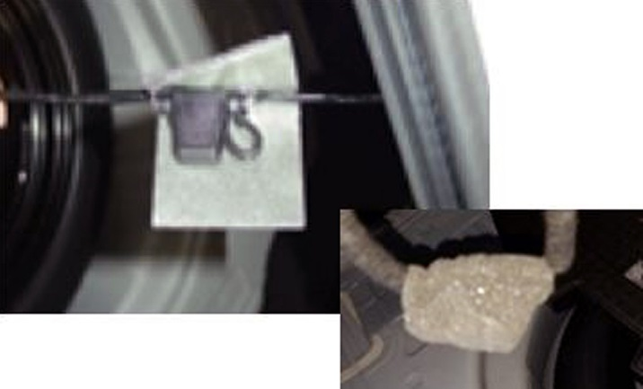
  - Locate fuse holder on the illuminated trunk sill harness and place 90mm x60mm foam tape over fuse holder prior to continuing with harness routing (Fig. 4-7).
90mm x 60mm Foam Tape
Fig. 4-7

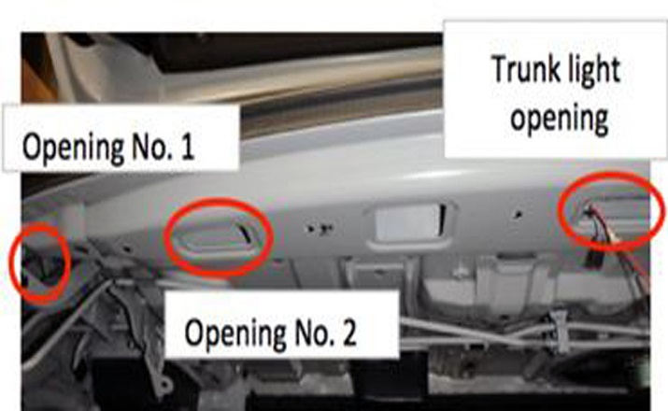
Fig. 4-8
  - Continue routing the illuminated trunk sill harness through Opening #1 located near LH of trunk lid hinge until harness appears near Opening #2 (Fig. 4-8).
Trunk light opening

Opening No. 1

Opening No. 2

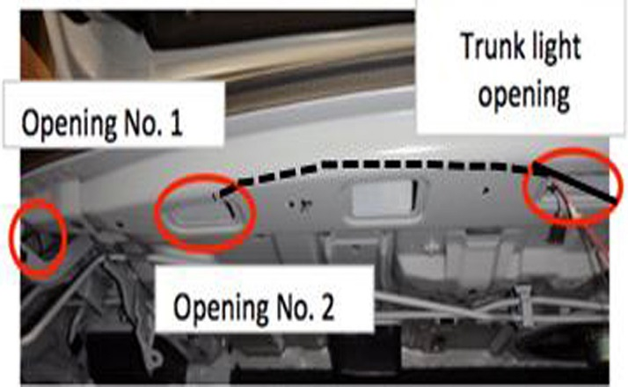
  - Continue routing the illuminated trunk sill harness through Opening #2 to the trunk light opening (Fig. 4-9).
Opening No. 2

Opening No. 1

Trunk light opening

Fig. 4-9

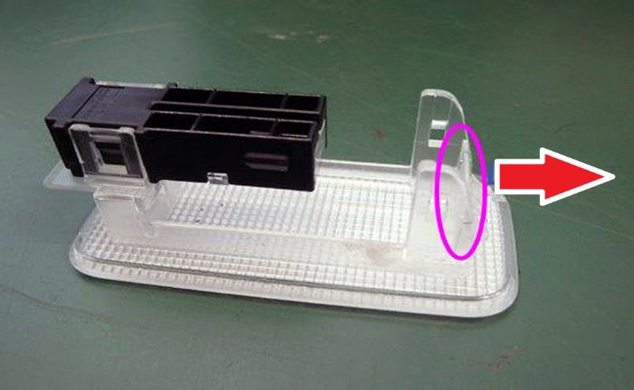
  - Ensure the trunk light lock hook is straight up prior to installation. If the lock hook is not straight up, pull the hook to the right until lock hook is straight (Fig. 4-10).
Fig. 4-10

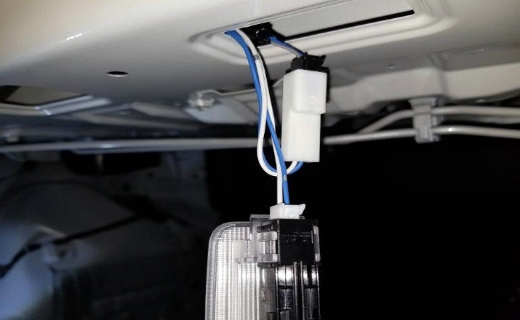
  - Connect the illuminated trunk sill harness male connector to the trunk light and attach vehicle side connector to the illuminated trunk sill harness (Fig. 4-11).
Fig. 4-11

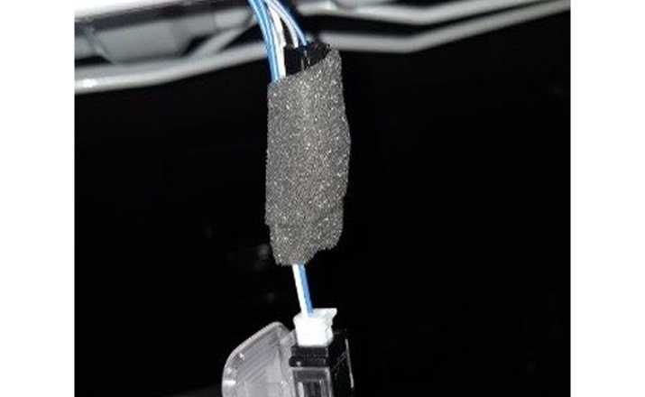
  - Place 90mm x 30mm foam tape around the connectors (Fig. 4-12).
Fig. 4-12

90mm x 30mm Foam Tape

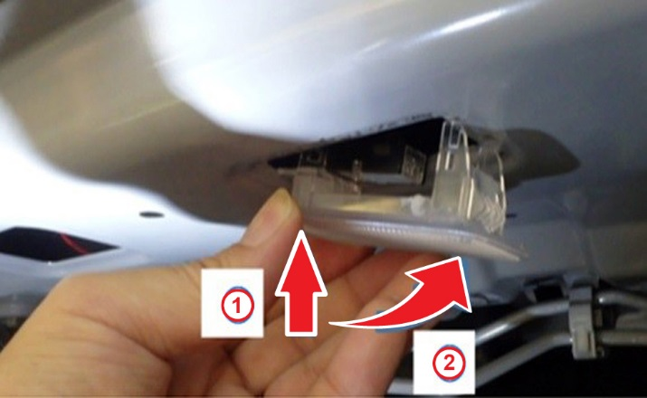
  - Install the trunk light (Fig. 4-13).
Fig. 4-13

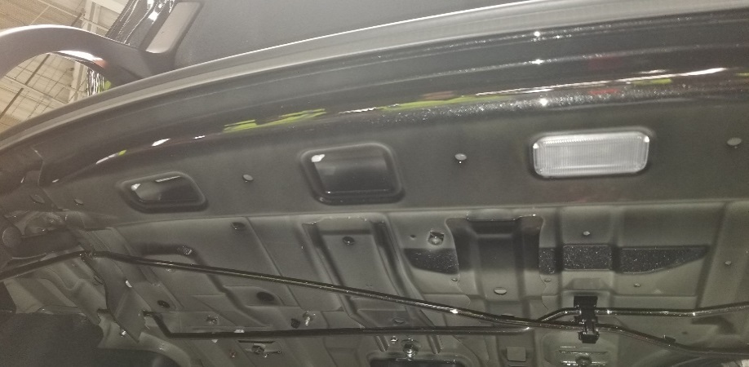
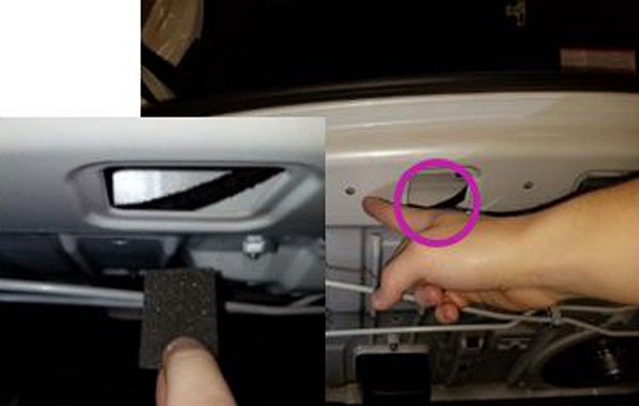
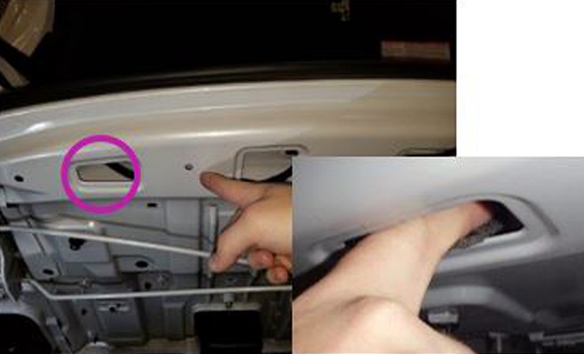
  - Use two (2) 45mm x 30mm foam tapes to hold the illuminated trunk sill harness to the vehicle body (Fig. 4-14).
45mm x 30mm Foam Tape
Front of Vehicle
Fig. 4-14

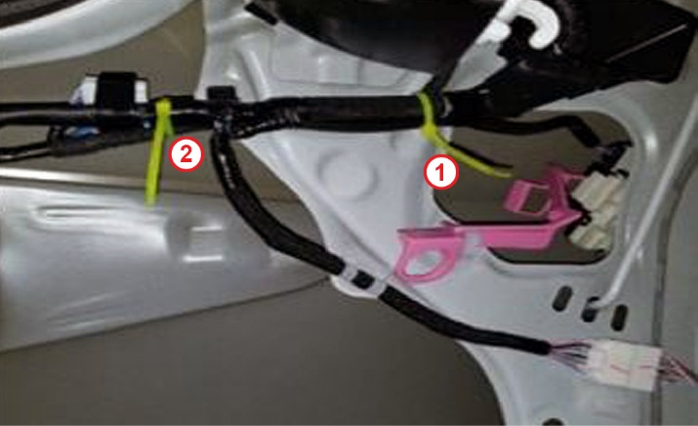
  - Using two (2) zip ties attach the illuminated trunk sill harness to the vehicle harness running down near the LH trunk opening (Fig. 4-15).
Fig. 4-15

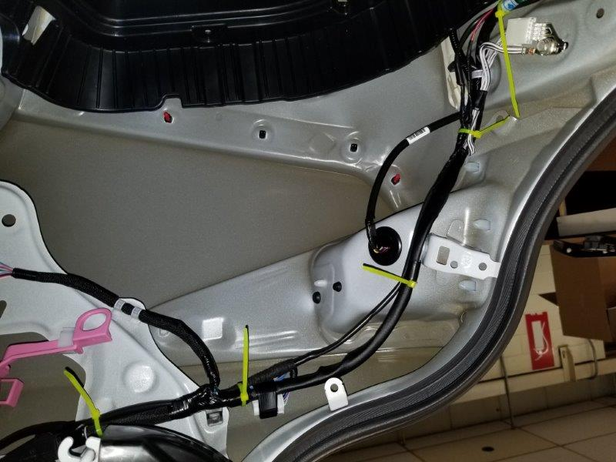
  - Using two (2) zip ties attach the illuminated trunk sill harness to the vehicle harness running down near the LH trunk (Fig. 4-16).

3

4

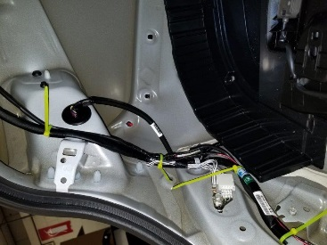
Fig. 4-16

  - Using one (1) zip tie attach the illuminated trunk sill to the vehicle harness running across the trunk opening (Fig. 4-17).

5

Fig. 4-17
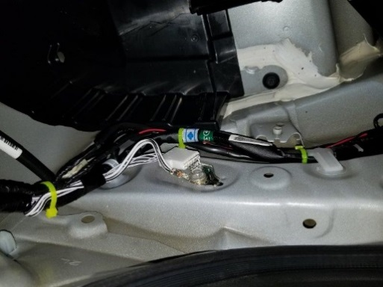
Fig. 4-18

6
  - Using one (1) zip tie attach the illuminated trunk sill to the vehicle harness running across the trunk opening (Fig. 4-18).

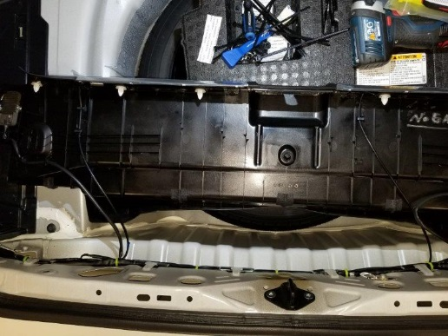
  - Using three (3) zip ties attach the illuminated trunk sill harness to the vehicle harness running across the trunk opening
(Fig. 4-19).

7

8
Fig. 4-19

9

  - Using two (2) zip ties attach the illuminated trunk sill harness to the vehicle harness running across the trunk opening (Fig. 4-20).

11
Fig. 4-20

10

Reassemble the Vehicle.
  - Reassemble the vehicle in the opposite order that it was disassembled.
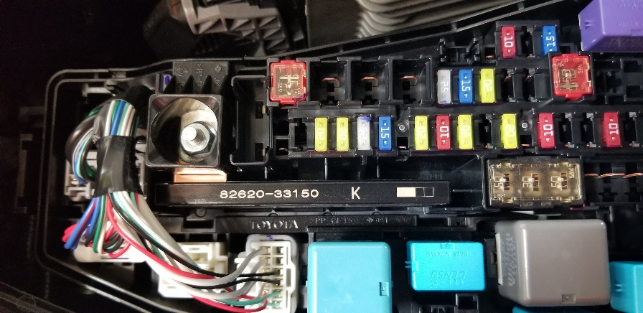
  - Remove DCC fuse located in driver side of hood if fuse was previously uninstalled (Fig 4-21).
Fig. 4-21
  - Position the negative (-) battery cable at the original factory location.
  - Tighten the nut to 48 inlbf (5.4 Nm).

Torque: 48 inlbf (5.4 Nm)
CAUTION: Do not touch the positive terminal.

Accessory Function Checks
Illuminated Trunk Sill
Verify correct part was installed

Vehicle Function Checks
Trunk Light
Torque Audit

Verify logos and spot lights illuminate when trunk lid is open.
    - RH Logo for Gas Vehicle = ES350
    - RH Logo for Hybrid Vehicle = ES300h

Verify trunk light turns on when trunk lid is open.

Perform torque audit on battery

48 lbf-in (5.4 N-m)

Vehicle Appearance Check
After accessory installation and removal of protective cover(s), perform a visual inspection.

Ensure no damage (including scuffs and scratches) was caused during the installation process.
(For PPO installations, refer to TMS Accessory Quality Shipping Standard.)

